CSC 533 Artificial Intelligence and Heuristic Programming
Bayesian Networks
Project 2

Chris Townsend & Shanon Clemmons
11/23/2009

Report

- Shortness of breath (dyspnea) may be due to one or more of tuberculosis, lung cancer, or bronchitis, or none of them.
  - Node
    - Dyspnea
    - Tuberculosis
    - Lung Cancer
    - Bronchitis
  - Links
    - Tuberculosis --> Dyspnea
    - Lung Cancer --> Dyspnea
    - Bronchitis --> Dyspnea
- A recent visit to Asia increases the chances of tuberculosis, while smoking is known to be a risk factor for both lung cancer and bronchitis.
  - Node
    - Asia Travel
  - Links
    - Asia Travel --> Tuberculosis
- The results of a single chest X-ray do not discriminate between lung cancer and tuberculosis.
  - Node
    - Chest X-Ray
  - Link
    - Lung Cancer --> Chest X-Ray
    - Tuberculosis --> Chest X-Ray

Statistical Data
See Attached Excel Worksheet

Network

Tables
P( Asian Travel)
0.5%

P(Smoking)
19.8%

Asian Travel | P(Tuberculosis| Asian Travel )
True | 5.00%
False | 4.11%

Smoking | P(Lung Cancer | Smoking)
True | 0. 23%
False | 0.06%

Smoking | P(Bronchitis | Smoking)
True | 18.82%
False | 4.45%

Tuberculosis | Lung Cancer | P(Chest X-Ray | Tuberculosis, Lung Cancer
False | False | 23.50%
False | True | 84%
True | False | 92%
True | True | 95%

Tuberculosis | Lung Cancer | Bronchitis | P(Dyspnea | Tuberculosis, Lung Cancer, Bronchitis)
False | False | False | 1.5%
False | False | True | 20.7%
False | True | False | 40%
False | True | True | 50%
True | False | False | 43.2%
True | False | True | 50%
True | True | False | 60%
True | True | True | 75%

ScreenShots

Asian Travel
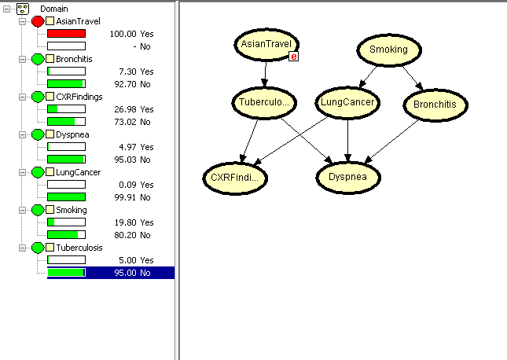

Smoker With Lung Cancer

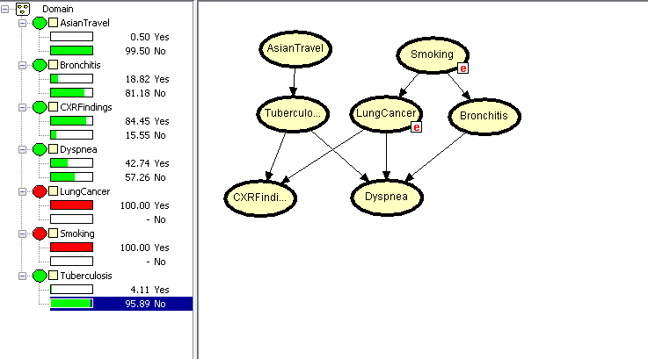

Tuberculosis , Lung Cancer & Bronchitis
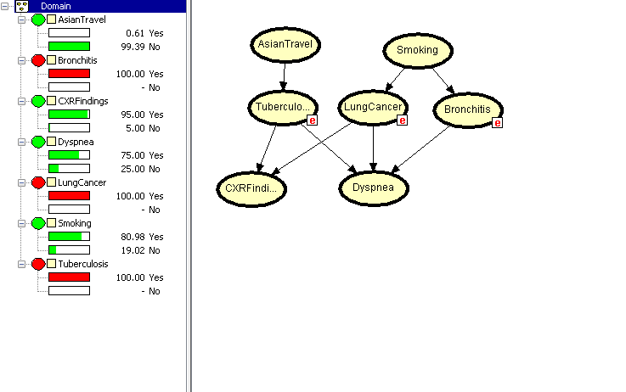

Contributions

- Chris
  - Research on Statistically Information - Excel Document
  - Initial Design of Bayesian Network

- Shanon
  - Report
  - PowerPoint

